 |   Welcome to the University of Leeds Campus  Getting here  Walking  The Worsley Building is a pleasant 20 minute walk from Leeds city station  Recommendation: Google maps tends to work well for finding your walking route to the Worsley Building. Simply navigate to “Worsley Building” and the following address should appear:  Worsley Building, Clarendon Way, Woodhouse, Leeds LS2 9LU  Things to note:  - The route will take you uphill (it is noticeably uphill so bear this in mind) alongside the centre of Leeds, passing impressive landmarks such as Leeds Art Gallery  - You will pass Leeds General Infirmary, as well as shops such as Tesco Express and Café Nero  - Once you turn down Clarendon Way, you will pass The Edge (our university gym), and shortly after passing the gym you will have the following view:  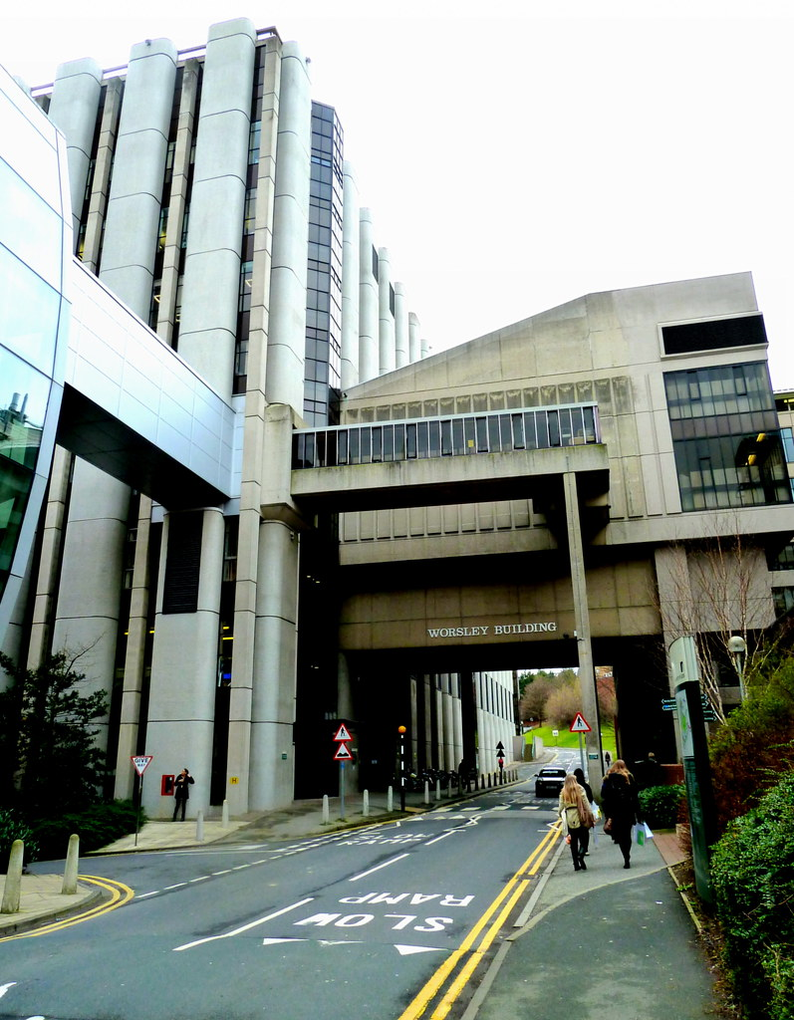  - This is the Worsley Building! Walk towards it and you will see the name on the building pictured  - From here, you are entering the building from Clarendon Way on “Level 4” (note that this is the level you arrive on via the routes named, ie. you don’t need to go up any steps)  - The signs inside the Worsley Building are very clear so take a look at these on entering.  Walking route example from Leeds train station to Worsley Building  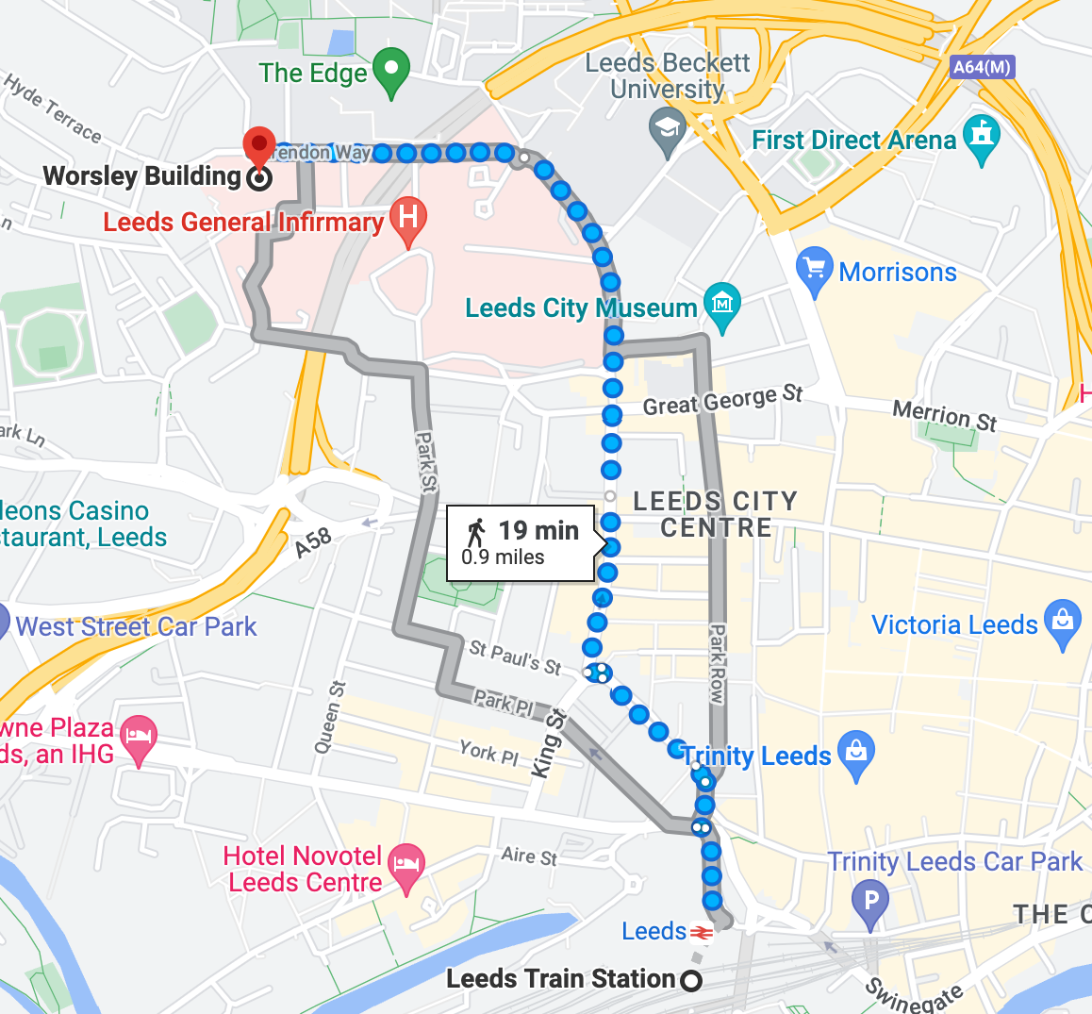  By train  - Leeds train station is well-connected to all major UK cities and has a fast and efficient service  - For train info and timetables visit National Rail  - Recommendation: Trainline is an app which tends to offer the cheapest tickets for travel: Trainline - buy tickets cheaper  By bike  - If you’re thinking about cycling to the university, we have secure bike racks and showers. For bike routes + info about cycling in the city visit Leeds City Council Cycling Pages  - If you are visiting by bike and have any questions or mechanical issues, the The Bike Hub can help – The Bike Hub also offers bike hire to staff and students  By bus  - For local bus information and timetables, visit the West Yorkshire Metro website and First Leeds and Arriva Yorkshire. Also, Leeds CityBus stops at the bus and train stations and the southern end of campus (near the back of Leeds General Infirmary A&E) every 10 minutes from 6.30 am to 7.30 pm Monday to Saturday  Tips  - If possible, walking/cycling can be a lot less stressful than parking in Leeds. However, if parking is necessary, the links provided are very helpful to support you with decisions surrounding this.  - There are many lovely cafés on campus including within the Worsley Building itself – LOMA Café on Level 9 is particularly nice and close by (open Mon-Fri 8:30am-3pm)  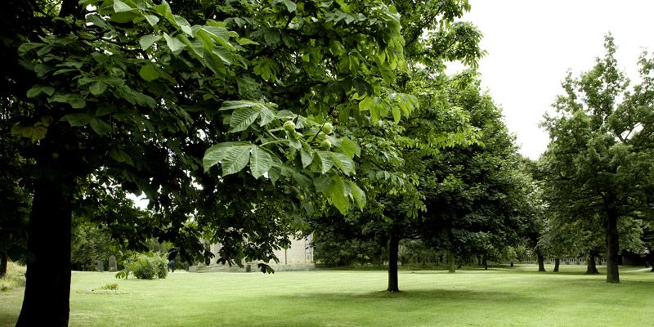  - The University of Leeds campus is well worth exploring – there are several beautiful outdoor spots to take your lunch or simply get some fresh air – visit Green Spaces for some suggestions
    - Find us
  Worsley Building
  Clarendon Way
  Woodhouse
  Leeds
  LS2 9LU
  By Car
  We are committed to reducing our carbon emissions so encourage participants to walk/cycle where possible.
  - Several city centre car parks nearby: Leeds City Centre Car Parks
  - For those who hold a blue disability badge, parking during core hours is available with a Blue Badge permit which can be acquired by contacting: carparking@leeds.ac.uk
  - Want to avoid parking in the city center? You can use the park and ride
  Useful links
  - Your Guide to Getting Around Leeds
  - Campus Map
  - Around Campus - all you need to know
  - Leeds City Life
  - Cafes on Campus
  - Accessibility Information
  Need help?
  Email:
  meddclin@leeds.ac.uk

